**LAB4: IT LAB**

**HRITK AJAY BANSAL**

**CSE A, 15**

**180905105**

Q1) class sub:

def f1(self, s1):

return self.f2([], sorted(s1))

def f2(self, curr, s1):

if s1:

return self.f2(curr,s1[1:]) + self.f2(curr + [s1[0]], s1[1:])

return [curr]

a=[]

n=map(int,input("enter a list of elements:\n").split())

print(sub().f1(n))

OUTPUT:

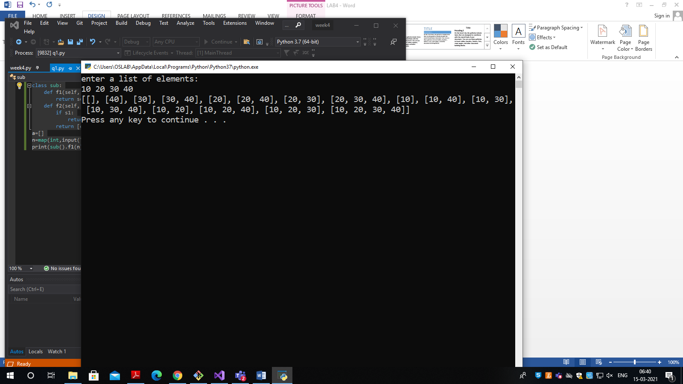

Q2) class Map:

def pairs():

flag=0

a=input("enter a list of numbers\n").split(' ')

targ=int(input("enter target value:\n"))

print("the pairs are:")

for i in range(len(a)):

for j in range(i+1,len(a)):

if(int(a[i])+int(a[j])==targ):

flag=1

print(i,",",j)

if(flag==0):

print("no such pair exists")

pairs()

OUTPUT:

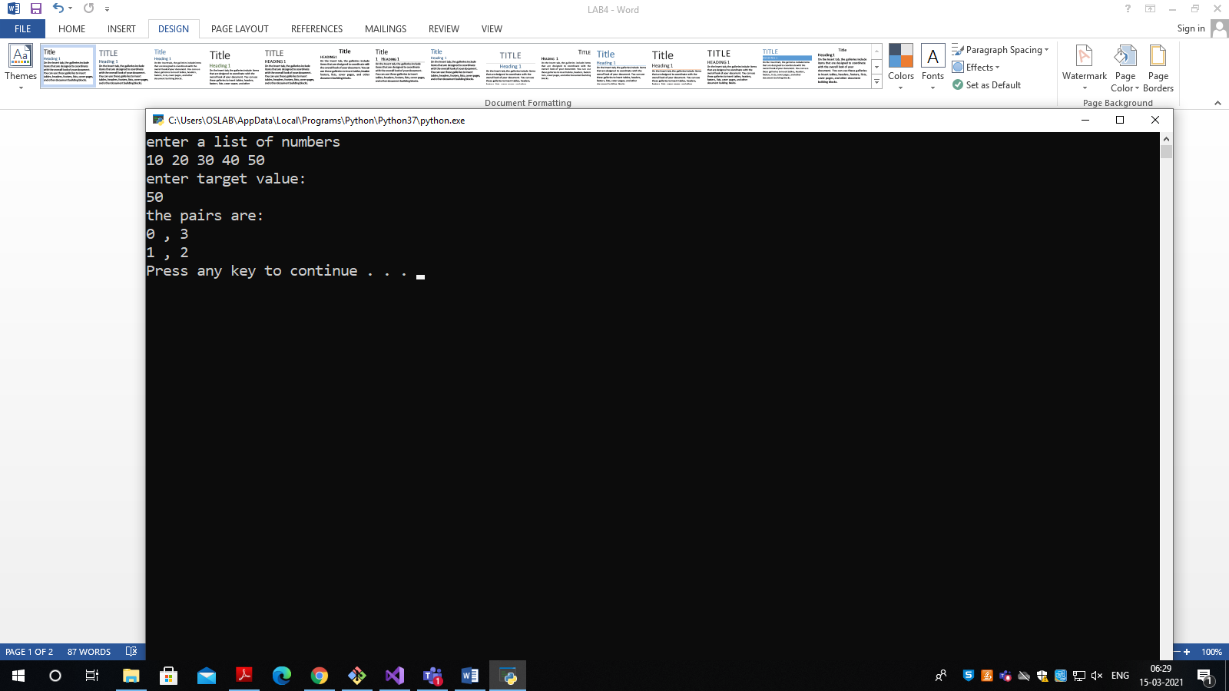

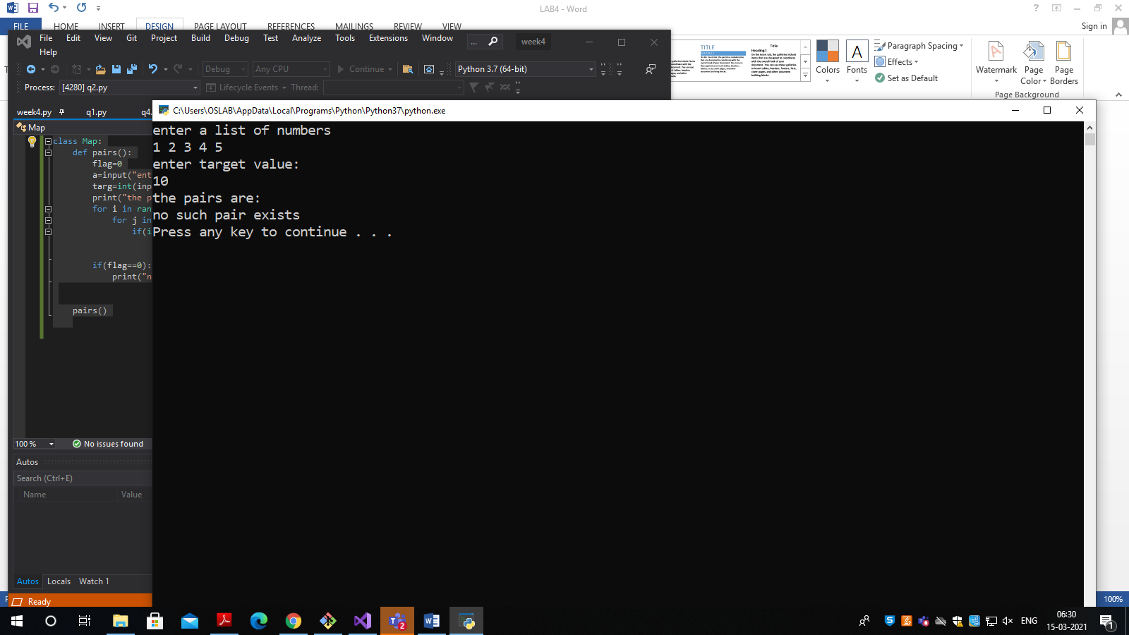

Q3) class Poww:

def poww(a, b):

res=a**b

return res

x=int(input("enter number x\n"))

n=int(input("enter number n\n"))

print("pow(",x,",",n,") : ",poww(x,n))

OUTPUT:

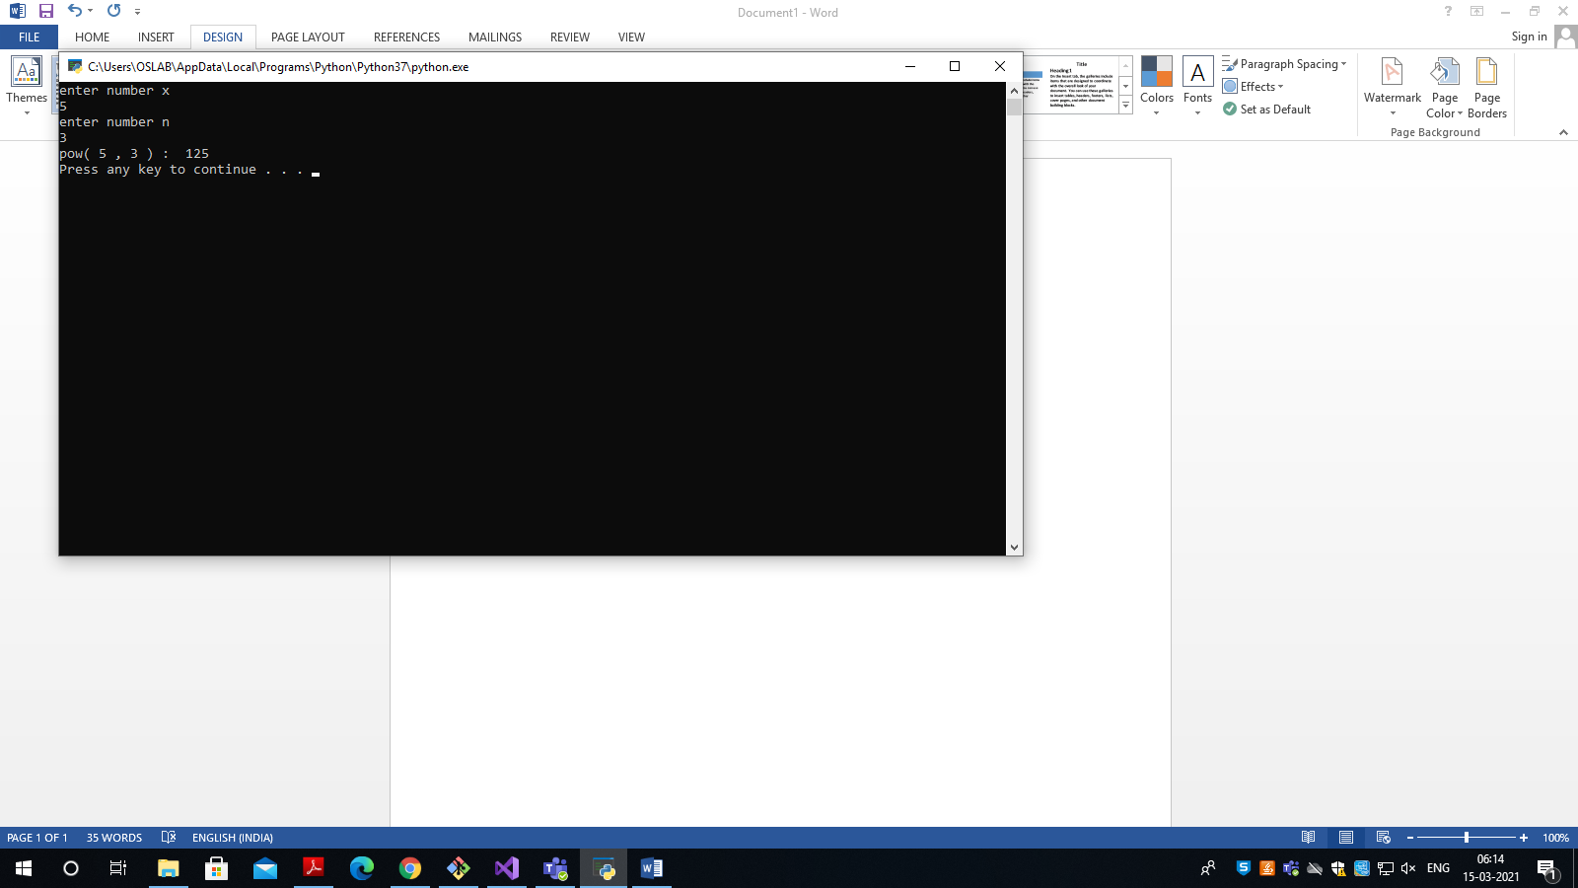

Q4) class Strings:

def get_String():

a=input("enter a string:\n")

return a

def put_String(a):

a=a.upper()

print("the uppercase string is: ",a)

put_String(get_String())

OUTPUT:

